Teacher Development Centre Chemistry

CHEMISTRY 2B EXAM

QUESTION/ANSWER BOOKLET

NAME:

TEACHER:

TIME ALLOWED FOR THIS PAPER:

Reading time before commencing Ten minutes
Working time for paper Two and one half hours

MATERIALS REQUIRED/RECOMMENDED FOR THIS PAPER:

TO BE PROVIDED BY THE SUPERVISOR
This Question/Answer Booklet
Separate Multiple Choice Answer Sheet
Separate Chemical Data Sheet

TO BE PROVIDED BY THE CANDIDATE
Standard Items Pens, pencils, eraser or correction fluid, ruler.
Special Items Calculators satisfying the conditions set by the Curriculum Council.

IMPORTANT NOTE TO CANDIDATES:

NO OTHER ITEMS MAY BE TAKEN INTO THE EXAMINATION ROOM.

IT IS YOUR RESPONSIBILITY to ensure that you do not have any unauthorised notes or other items of a non-personal nature in the examination room. Please check carefully, and if you have any unauthorised material with you, hand it to the supervisor BEFORE reading any further.

STRUCTURE OF THE PAPER:

Part | Format | Number of Questions | Questions to be Attempted | Marks Allocated | Suggested Time | Student Mark | Student %
1 | Multiple Choice | 30 | ALL | 60 (30%) | 45 min
2 | Short Answers | 11 | ALL | 70 (35%) | 65 min
3 | Extended Answer | 4 | ALL | 70 (35%) | 70 min
TOTAL |  |  |  | 200 (100%) | 180 min

INSTRUCTIONS TO CANDIDATES:

Reading Time: The examiners recommend that candidates spend the reading time mainly reading the exam instructions to Candidates and Parts 2, 3 and 4.

PART 1 - Multiple Choice Section

- Use a 2B, B or HB pencil to answer questions on the separate Multiple Choice Answer Sheet provided.
Do not use a ballpoint pen or ink pen.
- There is only one correct answer for each question. If you consider that two or more of the alternative responses are correct, choose the one you think is best.
Marks WILL NOT be deducted for incorrect answers.

PARTS 2, 3 and 4

- Use a ballpoint or ink pen. Do not answer in pencil.
- Write your answers in this Question and Answer Booklet.
- At the end of the examination make sure your name is written on the front of your Question/Answer Booklet and on your separate Multiple Choice Answer Sheet. Write your name on any pages which may have become detached.

CHEMICAL EQUATIONS

- For full marks, chemical equations should refer only to those species consumed in the reaction and the new species produced.
These species may be ions [for example Ag⁺_{(aq)}],
molecules [for example NH_{3(g)}, NH_{3(aq)}, CH₃COOH_{(l)}, CH₃COOH_{(aq)}]
or solids [for example BaSO_{4(s)}, Cu_{(s)}, Na₂CO_{3(s)}].

PART A.

Question 1 and 2 refer to the reaction of sulfur, S₈, with oxygen O₂, to form sulfur trioxide, SO₃, according to the following equation (which is not balanced). Balance the equation on scratch paper.

___S₈ (s) + ___O₂ (g) ^{catalyst} ___ SO₃(g)

Atomic weights:
Sulfur 32
Oxygen 16

- Which one of the following sets of coefficients, in the order given, will properly balance this equation?

a) 1, 1½, 1
b) 1, 24, 8
c) ⅛, 1, 1
d) 1, 12, 8

2. 32 grams of sulfur and 64 grams of oxygen are allowed to react until one of the reactants is completely consumed. The weight of SO₃ formed is

- 48g
- 64g
- 80g
- 96g

3. 34g of NH₃ are carefully weighed out. All statements concerning the weighed quantity of ammonia are true EXCEPT one. Which statement is WRONG?

- Two moles of NH₃ are present.
- Six moles of hydrogen atoms are combined with nitrogen atoms to form the ammonia.
- Two moles of nitrogen molecules, N₂, will produce 34g of NH₃.
- Approximately 12 x 10²³ molecules of ammonia are present in the container.

4. In a neutral solution, the [H⁺] is:

a) 1 x 10¹⁴ mol L⁻¹
b) zero
c) 1 x 10⁷ mol L⁻¹
d) equal to [OH⁻]

5. Which of the following pairs consist of a weak acid and strong base?

- sulfuric acid, sodium hydroxide
- acetic acid, ammonia
- acetic acid, sodium hydroxide
- nitric acid, calcium hydroxide

6. A 12.0 mol L⁻¹ solution of an acid that completely ionizes in solution would be termed:

- concentrated and weak
- strong and dilute
- dilute and weak
- concentrated and strong

7. Which on of the following solutions is most highly acidic?

- hydrogen chloride in water; concentration of H⁺ = 0.001M
- sodium hydroxide in water; concentration of OH─ = 0.200M
- ethanoic (acetic) acid in water; concentration of H₃O⁺ = 0.004M
- nitric acid in water; concentration of H⁺ = 0.0001M

8. An experiment to investigate the conductivity of two acids in aqueous solution was carried out, using the apparatus represented in the diagram.

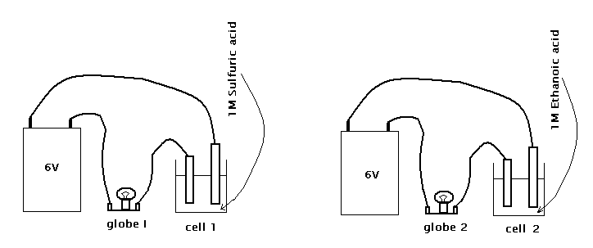

Cell I contains a 1 M solution of sulfuric acid (H₂SO₄).
Cell II contains a 1 M solution of ethanoic acid (CH₃COOH).
The results obtained when the electrical circuits are completed are
- globe I glows brightly:
- globe II glows dimly

The best explanation of these results is that:

a) pure sulfuric acid is ionic and the ions separate completely in aqueous solution, whereas the molecular ethanoic acid ionizes only slightly in water.
b) the proportion of ethanoic acid molecules which form ions is smaller than the proportion of sulfuric acid molecules forming ions.
c) each molecule of sulfuric acid ionizes to yield three ions whereas ethanoic acid yields only two ions per molecule.
d) each molecule of ethanoic acid only partially ionizes whereas each sulfuric acid molecule completely ionizes.

9. With solutions of ‘strong’ acids and ‘strong’ bases, the word strong refers to:

- concentration
- molarity
- solubility
- degree of ionization

10. According to the Bronsted-Lowry theory, water:

- acts as a base when it accepts a hydrogen ion
- is not an acid or a base
- can act as an acid by accepting hydrogen ions
- can accept but not donate hydrogen ions

  - The oxidation number of chlorine in potassium perchlorate, KClO₄ is

  - -3
  - -7
  - +3
  - +7

12. Which one of the following is an example of an oxidation – reduction reaction?

  - 2K₂CrO₄ + H₂SO₄ → K₂Cr₂O₇ + K₂SO₄ + H₂O
  - CaC₂ + 2H₂O → Ca(OH)₂ + C₂H₂
  - 2Na + Cl₂ → 2NaCl
  - BaSO₃ + 2HCl → BaCl₂ + H₂O + SO₂

13. Iodine reacts with hydroxide ions according to the reversible reaction

3 I₂(aq) + 6 OH –(aq) → IO₃–(aq) + 5 I –(aq) + 3 H₂O_{(l)}

Which two species are acting as oxidizing agents?

- Iodine molecules and iodate ions.
- Hydroxide ions and iodide ions.
- Iodate ions and iodide ions.
- Iodide ions and iodine molecules.

14. One method for determining the amount of alcohol in a persons’ blood is based on the reaction of dichromate ions with alcohol.

2Cr₂O₇²⁻(aq) +3C₂H₅OH(l) +16H⁺ (aq) → 4Cr ³⁺(aq) + 3CH₃COOH(l)+11 H₂O(l)

As the reaction proceeds the oxidation number of the Chromium atom changes from

- Positive 7 to positive 3.
- Positive 6 to positive 3.
- Positive 7 to zero.
- Negative 2 to positive 3.

15. Chlorine dioxide is prepared for use in water treatment plants by the reduction of sodium chlorate as shown by this unbalanced equation.

NaClO₃ + SO₂ + H₂SO₄ → ClO₂ + NaHSO₄

Which set of oxidation numbers has at least one not found in any of the reactants or products?

- ─2, +1, +5.
- ─2, +4, +6.
- +1, +2, +5.
- +4, +5, +6.

16. No noticeable reaction occurred when a strip of metal was added to dilute hydrochloric acid. Which of the following metals is it most likely to be?

- Copper.
- Potassium.
- Zinc.
- Iron.

17. Concentrated sulfuric acid is able to act as an oxidising agent. Which one of the following equations illustrates this ability?

- 2NaOH + H₂SO₄ → Na₂SO₄ + 2H₂O
- NaCl + H₂SO₄ → NaHSO₄ + HCl
- Zn + 2H₂SO₄ → ZnSO₄ + 2H₂0 + SO₂
- 2NH₃ + H₂SO₄ → (NH₄)₂SO₄

Questions 18 and 19 refer to this information:

100g of each of the sodium salts of fluoride, chloride, bromide and iodide are electrolysed, the sodium metal and the halogen are both separately recovered.

18. What mass of sodium is expected to be recovered from the NaCl?

- 39.3g
- 50.0g
- 60.7g
- 100g

19. Which of the salts would produce the greatest mass of halogen product from 100g of salt?

- Na F
- Na Cl
- Na Br
- Na I

Questions 20 to 22 refer to the following electrolytic cell:

20. Which of these statements is correct if the above cell is operating properly?

- Chlorine gas is forming at the platinum anode.
- Chlorine gas is reacting with the platinum electrode.
- Silver metal is forming at the platinum electrode.
- Silver metal is alloying with the platinum anode.

21. The half equations occurring while the cell is operating show that

- In forming one mole of silver, one mole of electrons are released.
- In forming one mole of silver, two moles of electrons are required.
- In forming one mole of chlorine gas, one mole of electrons are required.
- In forming one mole of chlorine gas, two moles of electrons are released.

22. The half equation identified with the correct electrode is shown below:

- Ag⁺ +e⁻ → Ag at the gold electrode.
- Ag⁺ +e⁻ → Ag at the CATHODE
- 2Cl⁻ +2e⁻ → Cl₂ at the ANODE
- 2Cl⁻ → Cl₂ + 2e⁻ at the Platinum

23. When aluminium metal is made from the electrolysis of molten Al₂O₃ the anodes are made of CARBON. Why is it used?

- Carbon is used because it is INERT.
- The oxygen gas product is effectively absorbed by the carbon.
- Forming CO₂ removes dangerous O₂ from the system.
- Carbon does not react with aluminium.

24. Which one of the following statements concerning the compounds CH₃CH₂CH₂CH₃ and (CH₃)₃CH is correct?

- They are members of different homologous series.
- They are saturated and unsaturated hydrocarbons.
- They are structural isomers.
- They have identical physical properties.

25. Which one of the following compounds does NOT exist in two or more structural forms?

- C₄H₁₀
- C₃H₇Cl
- C₂HCl₃
- C₂H₄Cl₂

26. A common feature of the alkanes is that they all have

- The same empirical formula.
- The same molecular formula.
- Similar chemical properties.
- Similar relative molecular masses.
27. Which one of the following compounds is NOT an alkane?

a) CH₄
b) CH₂CH₂
c) (CH₃)₃CH
d) C₃₀H₆₂

28. Which of the following compounds is LEAST likely to undergo addition reactions with chlorine?

- CH₂CH₂
- CH₃CHCH₂
- CH₂CHCl
- CH₃CH₂CH₃

29. Which one of the following compounds has NOT been named correctly?

- 1-methylpropane
- 2-methylbutane
- 2-chloropropane
- 2.2-dimethylbutane

30. Which of the reactions below is an addition reaction?

- C₂H₆ + Cl₂ → C₂H₅Cl + HCl

b) C₂H₅Cl C₂H₄ + HCl
AlCl₃

c) C₂H₄ + HCl → C₂H₅Cl

d) CH₃CH₂OH + Cr₂O₇²⁻ + H⁺ → CH₃COOH + Cr³⁺ + H₂O

PART 2: SHORT ANSWER SECTION
Answer questions in Part 2 in the spaces provided below.
_____________________________________________________________________________

1. Write equations for any reactions that occur in the following situations.

If no reaction occurs, write "no reaction". In each case describe in full what you would observe, including any colours, odours, precipitates (give the colour), gases evolved (give the colour or describe as colourless).

Your equations should refer only to the actual species involved (ionic equation).
Molecular equations will not be awarded any marks.

a) 20ml of 0.1M sulfuric acid solution is mixed with a similar volume of 0.2M sodium carbonate solution.

Equation:

Observation:

(3 marks)

b) 20ml of 0.5M hydrochloric acid is poured over freshly recovered iron filings (finely divided iron particles). The mixture is heated to 60ºC.

Equation:

Observation:

(3 marks)

c) Potassium iodide is melted and inert electrodes are placed into the molten salt. With 12 volts applied to the electrodes what half equation occurs at the ANODE?

Equation:

Observation:

(3 marks)

d) Benzene is shaken with iodine/water mixture. The mole ratio of benzene to iodine is about 1:1.

Equation:

Observation:

(3 marks)

2. Complete the following table by writing an appropriate example in the second column.

A substance that would produce a
group 1 ion and CO₂ gas when reacted
with 1M HCl
A solution that would cause a colourless
gas to be produced from the surface of
a clean zinc strip
A substance which when dissolved in
water is 0.1M but has a pH >3

The colour of a 1M NaCl solution when
a few drops of Universal Indicator is
added to it
Source of energy for an commercial
electrolytic cell

Name of a branched alkane with 5
carbon atoms

(6 marks)

3. Write balanced equations for these chemical reactions:

a) 2 – hexene + chlorine gas.

Equation:
(2 marks)

- Dilute nitric acid added to Potassium hydrogen carbonate solid.

Equation:
(2 marks)

4. Assign oxidation numbers to ALL the elements in the compounds and ions in the table below:

Species | CO₂ |  | NH₄⁺ |  | KClO₄
Elements
Oxidation Number

(4 marks)

5. Write the half equations for the electrolysis of MgBr₂ and identify where the oxidation and the reduction occurs (ie Type):

Half Equation 1: Type:

Half Equation 2: Type:
(4 marks)

6. Complete the table below with either a IUPAC name or structure.

Name | Structure
2,2,4 trichloroheptane
1,4 diiodo benzene
cis – 2 – butene
CH₃ CH₂ H
C = C
H CH₃
H H
│ │
H ─ C ─ C ─ CH₃
OR │ │
H ─ C ─ C ─ H
│ │
H H
(5 marks)
7. When 0.2M solution of BaCl₂ and H₂SO₄ are brought together a white solid BaSO₄ is formed and this sinks to the bottom of the beaker. If at the start we have 50ml of H₂SO₄ (0.2M). What would you observe when:

a) 20ml of BaCl₂ (0.2M) is added?

b) A further 30ml of BaCl₂ (0.2M) is added?

c) A further 50ml of BaCl₂ (0.2M) is added?

(1 mark)

Explain why these 3 observations would occur:

(2 marks)

8. Ammonia, NH_{3(aq)} , is described by Chemists as a weak base. Explain why it is so named, using an equation to help clarify what this means.

(2 marks)

9. The compound phosphine, PH₃, can be made by reacting phosphorus with concentrated sodium hydroxide solution according to this equation:

2 P₄ + 3 NaOH + 9 H₂O → 5 PH₃ + 3 NaH₂ PO₄

a) What evidence is there for this being an oxidation and reduction reaction?

(2 marks)

b) The phosphorus is said to have undergone a DISPROPORTIONATION reaction. What does this mean and explain using the products how this is such a reaction.

(3 marks)

c) Which elements in the above reaction DO NOT change their oxidation state in the overall reaction?

(1 mark)

10. Explain using molten NaCl why ion migration occurs in the electrolysis of this substance.

(2 marks)

11. Explain why Substitution reactions of alkanes is much less reactive than Addition reactions of alkenes.

(2 marks)

PART C Extended Response

1. (20 marks) Lead II nitrate reacts with potassium iodide in a precipitation reaction to produce yellow lead II iodide solid

(a) Write a balanced ionic equation for the reaction

(2)
(b) Describe an experiment you could carry out to show that the amount of lead iodide precipitated in a reaction between the two compounds is equal to the amount of lead nitrate. (You could describe the method stepwise or use a flowchart to show the sequence of steps)

(4)

(c) There would be sources of experimental error in this experiment. Give three.

(3)
(d) Given that lead is a nerve poison and the fact that it bioaccumulates, as has been demonstrated in marine organisms, what safety precautions would you take.

(2)

(e) In one experiment 0.60g of lead II nitrate and 2.6g of potassium iodide were dissolved and mixed together. Determine the number of mole of each substance and hence the limiting reagent in the reaction.

(6)

(f) The lead II iodide formed in (e) was filtered and the filtrate was then evaporated to dryness.
(i) What is the composition of the residue after evaporation of the filtrate?

(2)
(ii) What is the mass of the residue after evaporation.

(2)

2. (18 marks) In an experiment to determine the empirical formula of copper oxide, it was first dissolved in 2M sulphuric acid and then the ions precipitated from solution using excess granulated zinc. When the reaction was complete the large pieces of excess zinc were removed and sulphuric acid was added to dissolve the remainder. The copper residue was washed and transferred to an evaporating basin and then dried and weighed.

The experimental measurements are as follows:

Mass of copper oxide = 2.11 g

Mass of evaporating basin = 55.56 g

Mass of evaporating basin and copper = 57.22 g

(a) Calculate the mass of the copper residue

(2)
(b) Calculate the mass of oxygen in the copper oxide

(2)
(c) Determine the empirical formula of the copper oxide.

(2)
(d) How does your formula compare with the accepted formulas for copper oxides

(2)

(e) Write balanced equations for the reactions that occurred when

- copper oxide was added to sulphuric acid

_______________________________________________________________

- zinc was added to the copper sulphate solution

_______________________________________________________________

- sulphuric acid was added to the excess zinc

_______________________________________________________________ (6)

(f) There are two reasons why the empirical formula of magnesium oxide could not be determined using the same method. What are they?

(4)

3. (17 marks) One type of fire extinguisher depends on the reaction of sodium hydrogen carbonate with 20ulphuric acid to produce carbon dioxide.

(a) Write the equation for the reaction

(2)
(b) If a fire extinguisher is designed to hold 5.00 x 10² g of sodium hydrogen carbonate, calculate the mass of Sulphuric acid that would be required to react completely with the sodium hydrogen carbonate.

(3)

(c) If the volume of a fire extinguisher is 10.5 L with a 400mL container for the sodium hydrogencarbonate inside a 1.0L airspace, determine the maximum volume of acid that could be in the fire extinguisher and its concentration if it is to react with all of the sodium hydrogencarbonate.
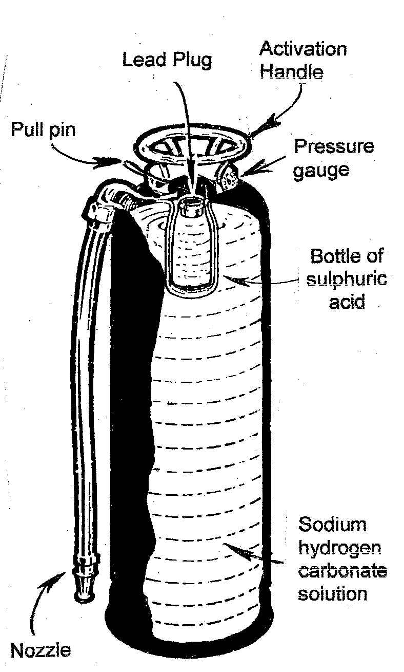

(3)

(d) Calculate the number of moles and mass of carbon dioxide produced.

(6)

(e) Determine the volume of the gas produced at STP.

(2)

4. (13 marks) Oxalic acid is a diprotic acid. It comes in the form of a white hydrated crystalline solid whose formula is H₂C₂O₄.2H₂O.

A solution of oxalic acid is prepared by dissolving 12.60 g of the
solid in distilled water to make the final volume up to 4.00 L.

(a) Determine the concentration of the oxalic acid solution in moles per litre.

(4)

(b) 25.00 mL of the diluted solution was found to require 42.00 mL of a potassium hydroxide solution to neutralise it.

Complete the equation

H₂C₂O₄ + KOH →

(2)
(c) Calculate the number of mole of oxalic acid in 25.00 mL

(3)
(d) Calculate the number of mole of potassium hydroxide that reacts with 25.00 mL of oxalic acid solution.

(2)

(e) Calculate the concentration of the potassium hydroxide solution.

(2)

END OF EXAM.

